Geometric Property Review for CC Math 7
Define the following words:

a) Isosceles Triangle: b) Complementary Angles:

c) Supplementary Angles: d) Vertical Angles:

e) Triangle Sum Theorem: f) Right Triangle:

g) Triangle Inequality Theorem h) Obtuse Triangle

Name each triangle by its sides and angles
a) b) c)
6 c m
8 c m
30
30
10 c m

____________________ ____________________ _________________

For # 1-4, find the measure of the missing angles
1) 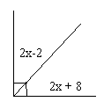 | 2) 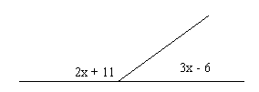
3) 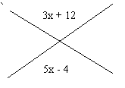  48  Find the measure of x | 4) 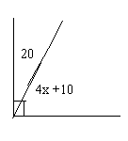
Name the type of angle formed in the diagram below:

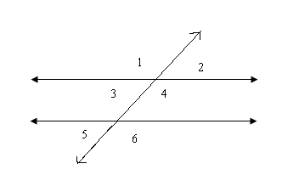

a) ∠1 and ∠3  b) ∠4 and ∠1  c) ∠2 and ∠3  d) ∠5 and ∠6 | 1) if ∠1 = 133, what is the measure of ∠2?  2) If ∠5 = 67, what is the measure of ∠6?  3) If ∠2 = 95, what is the measure of x if m∠3 = 4x - 5?  4) If ∠6 =2x +10 and ∠5=3x + 5, what is the value of x?
Find the measure of x and the missing angles
x  111  56 | 5x +7  3x +3

Find all the missing angles without using a protractor. Explain your reasoning as you go.

50

64 40
How can you use triangle side lengths to determine if a triangle can be made? Give an example and non-example.

Measure the following angles using a protractor.

