The North Carolina State Fair is looking for new games to showcase at next year’s event. Your task is to create a game to present on ___________________ to the rest of the class.
Game Requirements and Presentation: (35 points)
- The game must be winnable and a compound event. (required to earn all other points and preferable not a skill game i.e. shooting baskets, etc)
- A Title (5)
- Cost to play the game and prize amount(s). (5)
- Game rules/how to play. Player should be able to read all rules and understand how to play. (5)
- Game materials are present/constructed and playable on the due date.(15)
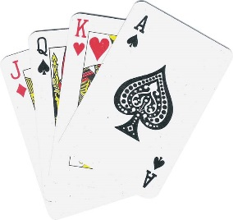
- Be creative and original. The game is won when a 3 is rolled or a head is flipped on a coin is not going to receive full credit. (5)
Game analysis: (65 points)
- A list of all possible outcomes (10)
- Include a calculated theoretical probability for winning vs. losing. (10)
- Include the amount of profit based on theoretical probability that should be made when the game is played 10 times, 50 times, and 100 times. (10)
- Have someone besides you play the game 25 times. Include the experimental results of the game played after 5 turns, 10 turns, and 25 turns. (5)
- Include how much profit based on the experimental results the game would have after it was played 25 times. (10)
- Analysis Paragraphs (20)
  - Paragraph 1: Analyze how the experimental results compares to the theoretical results.
    - Were the results the same/different and by how much
    - Should they be the same/different
    - What should happen to the experimental probability compared to the theoretical as you do more trials
    - Why did/didn’t the results represent the theoretical probability (what aspects of your game caused this to be the same or different)
    - What could you have done differently to make the game true to the predicted results.
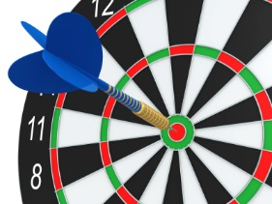
  - Paragraph 2: What did you learn?
    - What did you learn about probability from this project?
    - What did you need to change about your project and why?
Presentation needs to be neat and organized
Work needs to be organized by section as stated above
Due Dates:
__________ Idea approval
__________ Title, Rules/how to play, possible outcomes, theoretical probability, cost to play,
prize amount, amount of profit based on theoretical probability
__________ Materials to make game in class and adjusting game as necessary
__________ Experimental results and experimental profit
__________ Analysis paragraphs
__________ Presentation Day

