VOCABULARY:
General terms | Angle, side, ray, interior angle, protractor
Types of Angles | Acute Angle, obtuse Angle, Right Angle, Straight Angle
Types of Triangles to describe sides | equilateral triangle, Isosceles Triangle, scalene triangle
Types of Triangles to describe angles | Acute triangle, obtuse triangle, right triangle
Special Types of Angles | Complementary angles, Congruent angles, Supplementary Angles, Adjacent Angles

Part II: MEASURING ANGLES

Fill the blank with the appropriate vocabulary word. Shade the protractor with the range the angle describes.
A(n) ____________ angle is an angle that measures less than 90°.  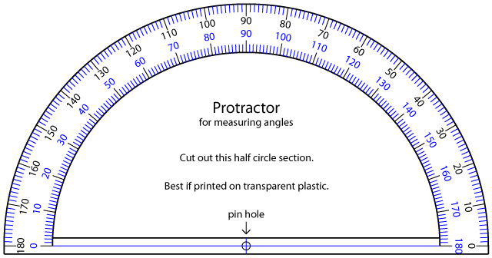 | A(n) ____________ angle is an angle that measures more than 90 and less than 180°.
A(n) ____________ angle is an angle that measures exactly 90°. | A(n) ____________ angle is an angle that measures exactly 180°.

Estimate the measure of the angle, measure the angle using a protractor, describe the type of angle.

Practice Page for Angles Unit ML 1 (Math 7)

For each angle below
- Write an estimate measurement
- Then use a protractor to find the actual measurement
- Identify the type of angle

- Estimated Measure:_______
Actual Measure: ________
Type of Angle: ___________

2.
Estimated Measure:_______
Actual Measure: ________
Type of Angle: __________

- Estimated Measure:_______
Actual Measure: ________
Type of Angle: ___________

- Estimated Measure:_______
Actual Measure: ________
Type of Angle: ___________

- Estimated Measure:_______
Actual Measure: ________
Type of Angle: ___________

