**ML #4: Equations, Tables and Graphs (Unit 7 – Math 7 Plus)**

|  |  |  |  |  |
| --- | --- | --- | --- | --- |
| **Review**   1. What is a **unit rate** and how do you find it? 2. What is a proportion? 2. What is **constant of proportionality**? 4. What are the characteristics of a   proportional relationship using a…   |  |  | | --- | --- | | Table | graph | |  |  | |

**Part 1: Determining an EQUATION for a table/Graph**

*Example: For every 6 cups of grape juice, mix in 3 cups of strawberry juice.*

Complete the table and create the graph*.*

|  |  |
| --- | --- |
| Cups of grape juice  (x) | Cups of strawberry juice (y) |
|  |  |
|  |  |
|  |  |
|  |  |
|  |  |
|  |  |
|  |  |

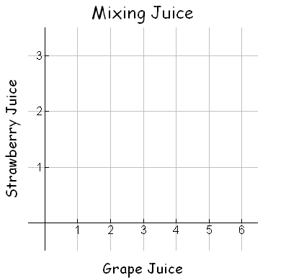

1. Is the relationship between cups of grape juice and cups of strawberry juice proportional? How do you know?

|  |  |  |
| --- | --- | --- |
| What do you have to do to the x value to get the y value? | So… | Y = |

1. What is the ordered pair where x = 1 🡪 (1, ____) What does this point represent?

You want to make different sized batches of juice that have the same exact flavor and strength as your original batch. Use your equation to find the missing amount of juice needed.

1. 23 cups of grape juice. How many cups of strawberry juice will you need?
2. 19 cups of strawberry juice. How many cups of grape juice will you need?

**Part 2: Interpreting Graphs**

A relationship between two quantities (i.e. time studying and grade on test) is proportional if the ratio between the quantities is always the same constant of proportionality. Proportional relationships can be represented by the equation *y = kx*, where *k* represents a constant (as proven in previous example).

**Ramon raced Angel and Carlos in a 50-meter dash**

**50-meter Dash**

1.  Ramon’s results are shown on the graph.

**DISTANCE IN METERS**

50

45

40

35

30

25

20

15

10

5

1. What does the shape of the graph tell

you about Ramon’s speed during the

race?

1. Explain how you can use the graph to

find the constant of proportionality/

1 2 3 4 5 6 7 8 9 10 11

unit rate for Ramon’s speed.

**TIME in seconds**

1. Angel’s data during the race can be described using the equation y = 4.5x. Explain how you can find the constant of proportionality for Angel’s speed from the equation.
2. Carlos ran the race at a constant speed. The table shows the distances Carlos traveled during different times in the race.



Distance in inches

50

45

40

35

30

25

20

15

10

5

|  |  |  |  |  |
| --- | --- | --- | --- | --- |
| **Time ( in seconds)** | **2** | **4** | **6** | **8** |
| **Distance (in meters)** | **9.5** | **19** | **28.5** | **38** |

1. Plot the data on the graph to show

Carlos’s speed during the race.

**TIME in seconds**

1 2 3 4 5 6 7 8 9 10 11

1. Explain how you can use the graph to

Find the unit rate for Carlos’s speed.

1. Who won the race? Explain how you know.
2. Suppose Ramon’s twin brother, Ricardo, also runs in the race. Ramon gives Ricardo a 10-m head start in the race, and they run at the same speed. The graph below shows the results.



50

45

40

35

30

25

20

15

10

5

Ramon

Distance (meters) Ricardo

1 2 3 4 5 6 7 8 9 10 11

time (sec)

1. Write an equation to represent Ramon’s position.
2. What do the points (0, 0) and (0, 10) on the graph represent?
3. Are the lines parallel? How do you know?
4. Ricardo runs at a constant rate of 5 m/sec and has a head start of 10 m. Write an equation of the line that represents Ricardo.
5. What is the unit rate for Ramon? Ricardo? Compare and make a statement about how the lines and equations relate.