**ML #2 - Angle Info and Transversals (Geometric Properties - Math 7+)**

**Part I: Fill in the vocabulary chart with a word and an example/picture.**

Vocabulary: Right Angle Complementary Angle Vertex

Angle Supplementary Angle Acute Angle

Obtuse Angle Adjacent Angle Ray

Straight Angle

**Part II: Missing Angle Measurements**

* **The idea is to use our knowledge of geometry and algebra to find missing angle measures.**

**Supplementary Angles:**

**a**

**b**

** a is the supplement of  b**

** b is the supplement of  a**

**EXAMPLES:**

**1) Find the value of x.**

**x 30˚**

**2) Find the value of x.**

**x 2x - 30**

**3) Find the value of x.**

**4x + 15 x**

**Complementary Angles:**

**b**

** a is the complement of  b**

** b is the complement of  a**

**a**

**EXAMPLES:**

1. **Find x. $x+40=90$**

**40˚**

**x**

1. **Find x.**

**x**

**3x + 20**

1. **Find x.**

**3x**

**5x -14**

**6) Find the missing measurements.**

**b**

**c**

**a**

118°

**7) Find the missing measurements.**

**x**

**2x +6**

**2x + 6**

**x**

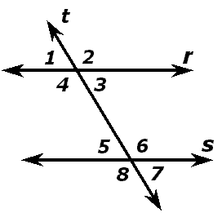**Part III: Parallel Lines**

**Name all pairs of**

**Corresponding Angles: Alternate Interior Angles:**

**_____________________________ ___________________________**

**Alternate Exterior Angles: Vertical Angles:**

**_____________________________ ___________________________**

**Supplementary Angles: ________________________________________**

**Example: In the above example line r and s are parallel and cut by a transversal, line t. If 3 is 68°, use what you know to find the measures of the rest of the angles in the diagram above.**

**1 ______ 5 ______**

**2 ______ 6 ______**

**3 ______ 7 ______**

**4 ______ 8 ______**

**Example: A line passes through 2 sides of a rectangle. The measure of**

**2 is 45˚. What is the measure of the other angles?**

1

3

5

7

2

4

6

8

**1 ______ 5 ______**

**2 ______ 6 ______**

**3 ______ 7 ______**

**4 ______ 8 ______**