**ML #2: Solids/Nets/Cross Sections (2D/3D Geometry – Math 7 PLUS)**

|  |  |  |
| --- | --- | --- |
| **PART 1: SOLID INFORMATION** | | |
| **Vocabulary** | **Definition** | **Illustration** |
| solid | Another name for a three-dimensional (space) figure |  |
| faces | The plane figures (sides) that make up a solid | face |
| edges | Where faces intersect | edge |
| vertex (vertices) | Where three or more edges intersect | vertex |
| net | A pattern you can fold into a solid figure |  |

**Examples of solids:**

|  |  |  |  |
| --- | --- | --- | --- |
| **Name** | **Description** | | **Illustration** |
| Rectangular Prism | * 2 rectangular bases * 4 rectangular sides | * faces ­­­\_\_\_\_ * edges \_\_\_\_ * vertices \_\_\_\_ | base  base |
| Cube | * 6 square faces * All faces are congruent | * faces ­­­\_\_\_\_ * edges \_\_\_\_ * vertices \_\_\_\_ |  |
| Triangular Prism | * 2 triangular bases * 3 rectangular sides | * faces ­­­\_\_\_\_ * edges \_\_\_\_ * vertices \_\_\_\_ | m_pav3_dia_03_iii |
| Cylinder | * 2 circular, congruent, parallel bases * lateral curved surface | * faces ­­­\_\_\_\_ * edges \_\_\_\_ * vertices \_\_\_\_ |  |
| Pyramid | * 4 or more faces * Triangular sides | * faces ­­­\_\_\_\_ * edges \_\_\_\_ * vertices \_\_\_\_ | 03 |
| Cone | * 1 circular base | * faces ­­­\_\_\_\_ * edges \_\_\_\_ * vertices \_\_\_\_ |  |
| Sphere | * perfectly round | * faces ­­­\_\_\_\_ * edges \_\_\_\_ * vertices \_\_\_\_ |  |

**PART 2: NETS OF SOLIDS**

|  |  |
| --- | --- |
| DIRECTIONS: Draw a net for each solid below. Use graph paper to construct the solids from your nets. | |
| Cube | Rectangular Prism |
| Cylinder | Triangular Prism |
| Square Pyramid | Triangular Pyramid |
| Cone |  |

**PART 3: CROSS SECTIONS**

Below are three cross sections of a pyramid with a square base:

|  |  |
| --- | --- |
| http://intermath.coe.uga.edu/dictnary/images/solids/1crssect.gif | If the pyramid is cut with a plane parallel to the base, the intersection of the pyramid and the plane is a square cross section. |
| http://intermath.coe.uga.edu/dictnary/images/solids/2crssect.gif | If the pyramid is cut with a plane passing through the top vertex and perpendicular to the base, the intersection of the pyramid and the plane is a triangular cross section. |
| http://intermath.coe.uga.edu/dictnary/images/solids/3crssect.gif | If the pyramid is cut with a plane perpendicular to the base, but not through the top vertex, the intersection of the pyramid and the plane is a trapezoidal cross section. |

Discovering Plane Sections: Draw the 2-D shape made from the given cut

|  |  |
| --- | --- |
| Cube Plane Sections: Shapes Found |  |

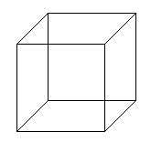

|  |  |
| --- | --- |
| Rectangular Prism Plane Sections: Shapes Found |  |

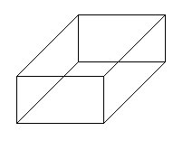

|  |  |
| --- | --- |
| Triangular Prism Plane Sections: Shapes Found |  |



|  |  |
| --- | --- |
| Cone Plane Sections: Shapes Found |  |

  

|  |  |
| --- | --- |
| Cylinder Plane Sections: Shapes Found |  |

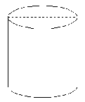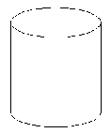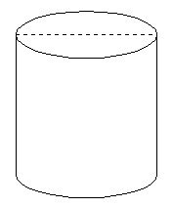

|  |  |
| --- | --- |
| Sphere Plane Sections: Shapes Found |  |

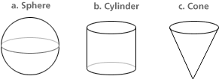  

**http://www.glencoe.com/sites/pdfs/impact\_math/ls1\_c2\_cross\_sections.pdf**