ML #2: Cross Sections (3Dimensional Unit – Math 7)

CROSS SECTIONS: When a solid is cut with a 2-D plane, what the view looks like where the cut was made.

What DO You Think??
For each figure below, draw the 2-D shape that would result in cutting the 3-D figure in the different directions.

 | Horizontal Cut  (parallel to the base) | Vertical Cut  (perpendicular to the base) | Diagonal Cut  (from lower left to upper right)

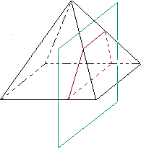
Below are three cross sections of a square pyramid. What is the shape of the base?
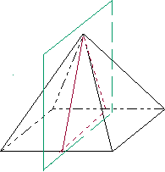
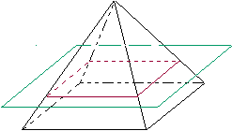
Draw a picture of each cross section

Discovering Plane Sections: Draw the 2-D shape made from the given cut

2. Below each figure, draw the shape that you think would be created if the dotted line represents a cut that a plane made through the figure.

3. Below each cylinder, draw the shape that you think would be created if the dotted line represents a plane that cuts through the figure.

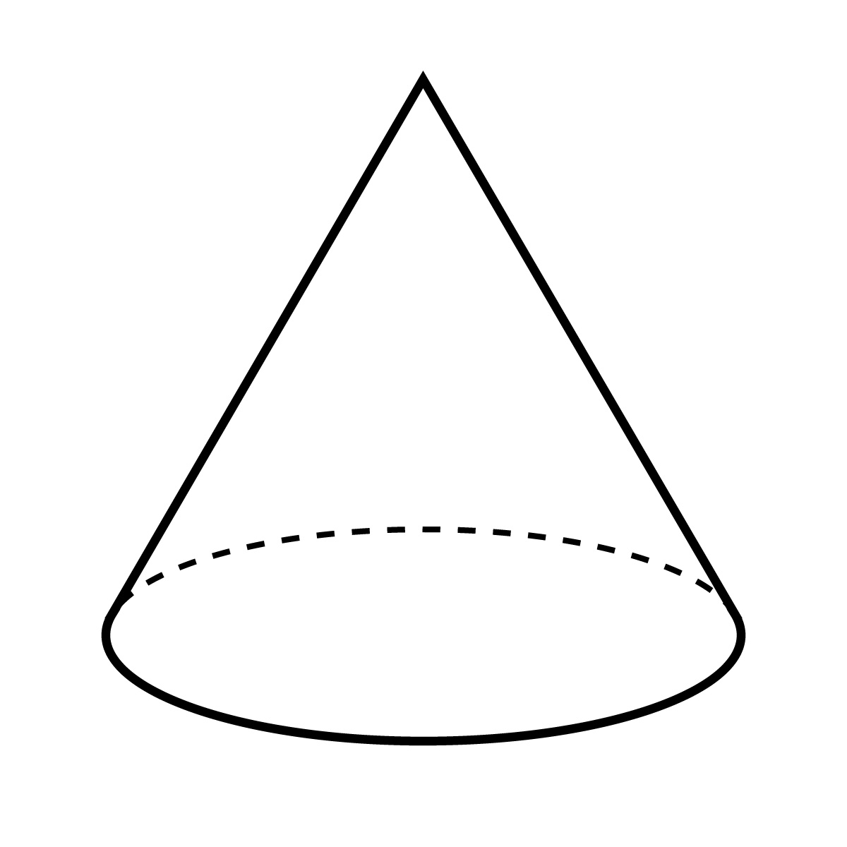
4. Below each cone, draw the shape that you think would be created if the dotted line represents a plane that cuts through the figure.

When slicing a cross section that is parallel to the base, the cross section shape will always
__________________________________________________________.

