**ML #4: Volume of Square Pyramids, Cones Cylinders and Spheres (Math 7 Plus)**

**Understanding Volume of Right Square Pyramids**

* Find the volume of each rectangular prism and then find the ratio of the volume for the pyramid to the volume of the rectangular prism in each row. Be sure to fully simplify the ratio.

|  |  |  |
| --- | --- | --- |
| Rectangular Prisms | Pyramids | Ratio of Volumes  Pyramid : Rectangular Prism |
|  |  |  |
| Side Length of Square Base: 6 cm  Height of Prism: 10 cm  Volume: _________________ | **Side Length of Square Base: 6 cm**  **Height of Pyramid: 10 cm**  **Volume: 120 cm3** |  |
| Side Length of Square Base: 9 in  Height of Prism: 15 in  Volume: _________________ | **Side Length of Square Base: 9 in**  **Height of Pyramid: 15 in**  **Volume: 405 in3** |  |
| Side Length of Square Base: 18 ft  Height of Prism: 7 ft  Volume: _________________ | **Side Length of Square Base: 18 ft**  **Height of Pyramid: 7 ft**  **Volume: 756 ft3** |  |

* Looking at the ratios you wrote for the volume of the pyramid to the volume of the rectangular prism, what conclusions can you make?
* Can you use this conclusion to write a formula for how to find the volume of a right square pyramid?

**VOLUME OF A PYRAMID:**

* 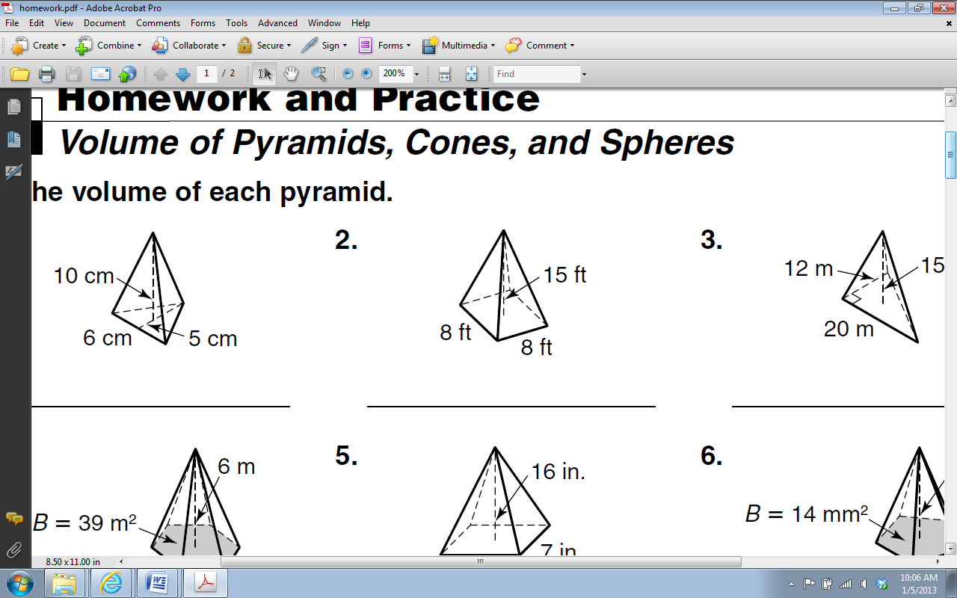**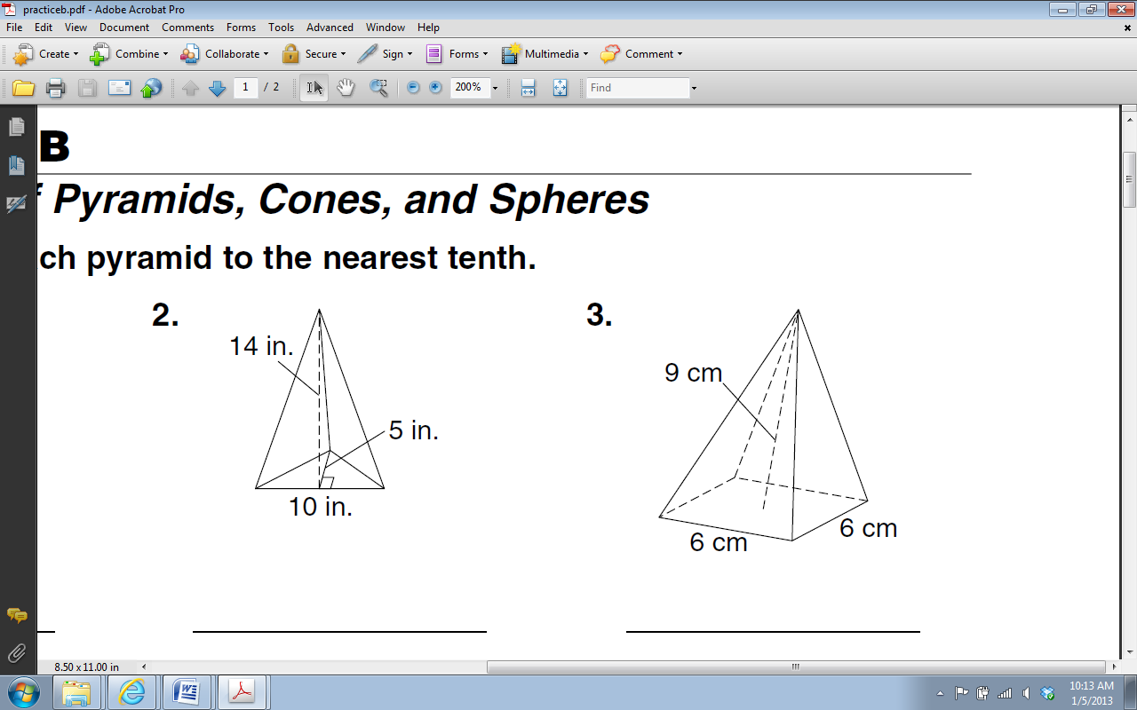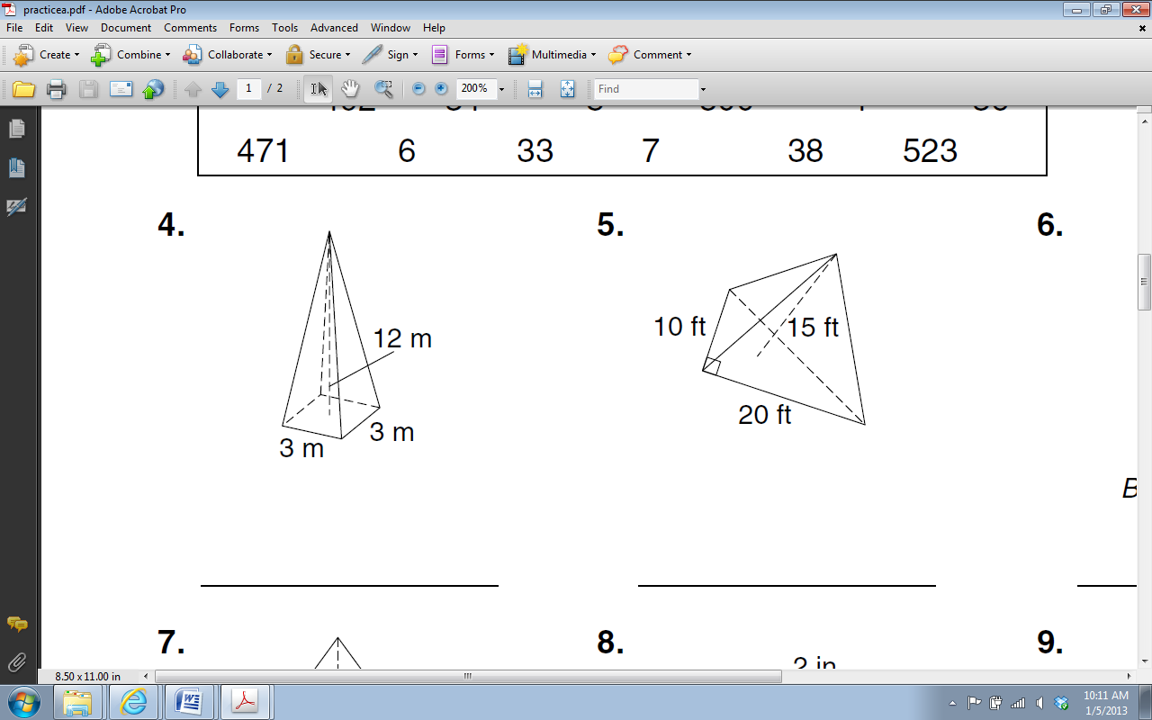Use your formula to find the volume of the following right square pyramid:**

**3)**

**1)**

**2)**

**UNDERSTANDING VOLUME OF CONES**

**INVESTIGATION:**

* How many cones of rice do you think would be needed to fill a cylinder that had the same radius and height as the cone?
* Fill the cone with rice and then empty it into the cylinder. Keep note of how many cones of rice can fit into the cylinder.

Number of cones of rice that can fit into the cylinder _______________

Recall what the formula for the volume of a cylinder is: ________________________

* By looking at the relationship between the amounts of rice it took to fill the cylinder, we can see that the volume of _____ cones equals the volume of a similar sized cylinder.
* Using mathematical terms we can then find a formula for the volume of a cone.

**Therefore the formula for finding the volume of a cone is: ________________________**

**VOLUME OF A CONE:**

* **Use your formula to find the volume of the following right square pyramid:**

**1)**

**2)**

5 in

20 in

14 in

18 in

**3)** A cone with a radius of 34 cm and a height of 23 cm.

**UNDERSTANDING VOLUME OF SPHERES**

* A sphere can be enclosed with a cylinder, which has the same radius and height of the sphere (Note: the height of the cylinder is twice the radius of the sphere).
* If the sphere is flattened, it will fill $\frac{2}{3}$ of the cylinder. Based on this model, the volume of a sphere is the $\frac{2}{3}$ the volume of a cylinder with the same radius and height. The height of the cylinder is the same as the diameter of the sphere or 2*r*.

r

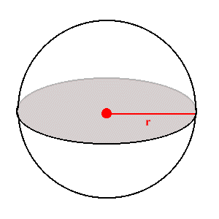

h

* Using this information, the formula for the volume of the sphere can be derived in the following way:

V = (π r2)h volume of a cylinder

V = (π r2)h multiply by $\frac{2}{3}$ since the volume of a sphere is $\frac{2}{3}$ the cylinder’s volume

V = r2 2r Substitute 2r for height since 2r is the height of the sphere

**V = π r3 Simplified Volume of Sphere Formula**

**VOLUME OF A SPHERE:**

**Examples: Find the volume of the solids**

1. 

10 in

1. 

6 in