**ML #4 – Translations (Unit 8 – math 7 Plus)**

* **Transformations:**
* **Rigid transformations:**
* **Four types of Transformations:**

**TRANSLATIONS**

* When working with any **TRANSFORMATIONS** the original points create the **PRE-IMAGE**. You can name the points using letters.
* For example, A (4, 5) tells you that “point A is located at position 4, 5 on the graph.” Once the point is moved to its new position, it is called a “prime point” and named like this: A’ (read as “A prime.”)

The figure is now called the **“IMAGE.”**

* **TRANSLATIONS** involve moves that are either right-left, up-down, or a combination of these.

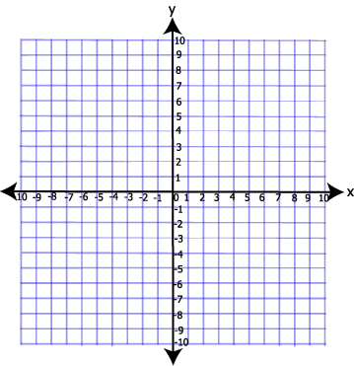- - - - - - - - - - - - - - - - - - - - - - - - - - - - - - - - - - - - - - - - - - - - - - - - - - - - - - - - - - - - - - - - - -

**METHOD 1**

**Example 1:** Create a pre-image by graphing and labeling the following points:

**A(-3, 2), B(-3, 6), C(-7, 2)**

Now take each point and move it 8 units

right and then label the new points as “primes”.

You have modeled a **TRANSLATION**.

Name the new prime coordinates below:

A’(___,___), B’(___,___), C’(___,___)

Did the shape or size of the figure change? ______

Look at the new “x” numbers. What do you notice happened to the “x” part of each ordered pair? __________________________________________________

Why do you think it was the x affected and not the y? _____________________________________________

What type of move do you think would affect the y? ______________________________________________

**Example 2:** Look at the graphed image below. Write in the coordinates for the pre-image and the image. Make sure that you label the coordinates that you list.

Pre-Image Coordinates Image Coordinates

**A**

**B**

**C**

**D**

**A’**

**B’**

**C’**

**D’**

a) How did you determine which was the

pre-image and which was the image?

_______________________________

_______________________________

b) What happened to the “y” part of the coordinates?_________________________________

c) Why?_____________________________________________________________________

**If you are moving UP or DOWN, the _____ part of your ordered pair will change.**

**If you go up, you will ___________ the number of units to the original “*y*.”**

**If you go down, you will ____________ the number of units from the original “*y*.”**

**If you are moving RIGHT or LEFT, the _____ part of your ordered pair will change.**

**If you go right, you will _____________ the number of units to the original “*x.”***

**If you go left, you will _____________ the number of units to the original “*x.”***

**Example 3:** Graph and label the following points and then translate 3 units left and 2 units up. Label and list your new prime points.

M(5, 8) M’(____,____)

A(0, 6) A’(____,____)

P(-3, -2) P’(____,____)

Now describe what happened to

each part of the ordered pairs:

(x _______, y________)

**Example 4:** Describe the

translation that you see below.

2

1

**METHOD 2**

**Can you give the new prime points without creating the graphs for these two translations?**

**Example 1:** Translate 2 units left and 4 units up. **Example 2:** Translate 5 units right and 3 units down.

A (5, -2) (5_____, -2______) A’(____,_____)

M(2, 6) (2_____, 6_______) M’(____,____)

B (0, -3) (0_____,-3_______) B’(____,____)

C (3, 5) (3_____, 5______) C’(____,_____)

W(-2, 5) (-2_____, 5_______) W’(____,____)

T (1, -7) (1_____,-7_______) T’(____,____)

* **Translations:**
* **Two Methods for Translations:**