**ML #5: Slope and Similar Triangles (Unit 6 - Math 7 Plus)**

**Part 1: The Slope of Four Types of Lines**

|  |
| --- |
| **The graph of a linear equation will form a line that travels one of the following ways:** |

**Directions: For each pair of points, plot the ordered pairs and draw a straight line through them. Label the line as one of the four types shown above.**

1. (-1, 1) and (4, 3) 2. (-2, 1) and (3, 4)

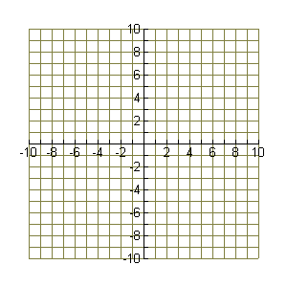

3. (-1, 5) and (2, 2) 4. (0, 4) and (2, 1)



5. (-5, 2) and (6, 2) 6. (4, 4) and (0, 4)

 7. (4, 2) and (4, -6) 8. (7, 1) and (7, 8)

**\*Compare the graphs and look for similarities and differences.**

|  |
| --- |
| **Conclusion**   1. **If the graph of a line slants upward from left to right, than the slope of the line is __________________.** 2. **If the graph of a line slants downward from left to right, than the slope of the line is __________________.** 3. **If the graph of a line is horizontal, than the slope of the line is _______.** 4. **If the graph of a line vertical, than the slope of the line is said to be __________________.** |

**Part 2: Similar Triangles and Slope**

**Label the points with their coordinates. Connect points C and F to the line to form right triangles.**



**F(___,___)**

11

10

**E(___,___)**

9

8

7

6

**D(___,___)**

**C(___,___)**

5

4

**B(___,___)**

3

2

**A(___,___)**

1

1 2 3 4 5 6 7 8 9 10 11 12 13 14 15 16 17

1. **For each triangle, find the ratio of the length of the vertical leg to the length of the horizontal leg.**

**TRIANGLE ABC:  Solution: _______**

**TRIANGLE DEF:  Solution: _______**

1. **Compare the two ratios. What do you notice?**
2. **What statement could be made about the two triangles? Although they are different sizes they are ___________________________.**
3. **Both ratios that you found describe the “slope” of the line. Although they are different ratios, they both describe the “steepness” of the same line.**

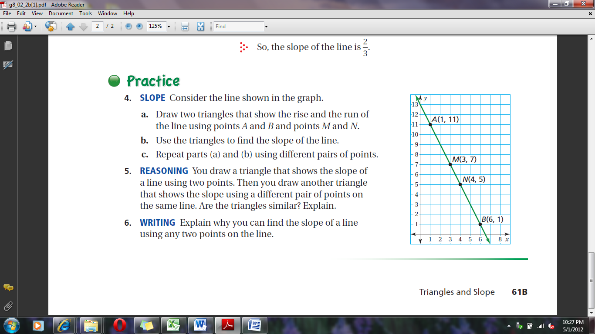**Consider the line shown on the graph.**

1. Find a point for each of the given lines

below that you can use to create right

triangles. Plot the point and record

the coordinates of your new points**.**

1. Use the triangles created by your new

points to find the slope of the line.

Remember to pay attention to the direction

you move and note it as positive

or negative.

**Slope of $\overline{AB}$ =**

**Slope of $\overline{MN}$**

**Slope of $\overline{AN}$ =**

**Slope of $\overline{MB}$ =**

1. Compare these ratios or ***slopes***.

1. Explain how you can find the slope of a line using any two points on the line.

**SLOPE: $\frac{rise}{run}$ = $\frac{difference in y}{difference in x}$**