**ML #5 - Composition of Transformations**

**Vocabulary**:

Composition of Transformation: A composition of two transformations is a transformation in which a second transformation is performed on the image of a first transformation

Glide reflection: a composition of a translation and a reflection in a line parallel to the direction of the translation

**Example 1:**

Given DEF with D (3, 1), E (-3, 2), and F (-2, -2). Find the image points after:

1. A reflection over the x-axis, then a dilation of 

Complete one transformation at time—IN ORDER.

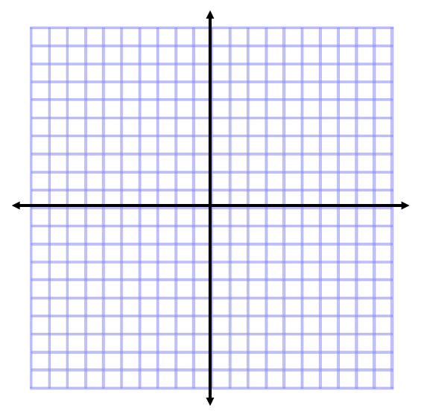

1. A translation of (x, y) → (x - 5, y + 2), then a rotation of 90° counter clockwise

c. A reflection over the y-axis, then a translation of (x, y) → (x + 1, y – 4)



d. Triangle DEF has vertices D (3, -4), E (2, -2), and F (0, 1). Find the coordinates after a glide reflection composed of the translation (x, y) → (x, y - 2) and a reflection in the y-axis.



Practice For ML #5 – Composition of Transformations

Given DEF with D (-5, 7), E (-3, 2), and F (-4, 8). Find the image points after:

1.  A rotation of 180° counter clockwise, then a dilation of 2.
2. A reflection over the x-axis, then a rotation of 270° counter clockwise
3. Triangle ABC has vertices A (3, 2), B (-1, -3), and C (2, -1). Find the coordinates after a glide reflection of (x, y) → (x + 3, y) and a reflection over the y-axis.