ML #6: Surface Area of Cylinders (3Dimensional Unit – Math 7)

Part I: Surface Area of Cylinder Explorations
Use the net to find the surface area of the cylinder

 | Face 1 | Face 2 | Lateral side
Shapes:
(draw shape and label with dimensions)
Area formula to find the face:
Formula breakdown
Complete formula

Ways to find Surface area of a cylinder:

Find the surface area of each of the cylinders below.
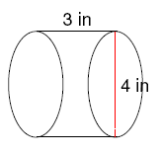
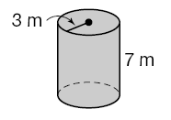
1. 2.

