Notes – Area Models/Geometric Probability Name: __________________________

Geometric Probability – The probability of landing in a specific region of a target. It is the ratio of the area of the shaded region to the area of the target.
**When determining geometric probability with targets, we are assuming that...
- The object lands within the target area.
- It is equally likely that the object will land anywhere in the region.
- Your friend has an interesting collection of dartboards. If you throw a dart at random and it is guaranteed to hit the dartboard but you only get a point if it hits the shaded region, what is the probability that you will get a point on the dartboard below?

- Determine the area of the entire dartboard. |  | 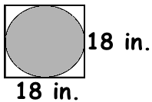
- Determine the area of the shaded region.

- Determine the probability by comparing the area of the shaded region to the area of the entire dartboard. Be sure to convert your probability to a percent.

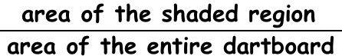

- Does your answer seem reasonable?

- During Raleigh’s Freedom Balloon Fest, each balloon tries to land in a target zone. The target zone is a square that has a side length of 25 ft. The target zone is in the middle of a rectangular field that is 325 feet by 350 feet. Find the probability that the balloon lands in the target zone.

- If the area of the target zone is doubled, how does the probability change? | - If each side of the target zone is doubled, how does the probability change?
Practice
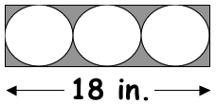 | 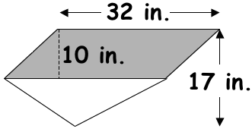
Area of the rectangle: _________________  Area of one circle: ____________________  Area of three circles: __________________  Area of shaded region: _________________  : _____________________  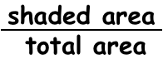  Probability: __________________________ | Area of the parallelogram: _______________  Area of triangle: ______________________  Area of total figure: ___________________  Area of shaded region: _________________  : _____________________  Probability: __________________________
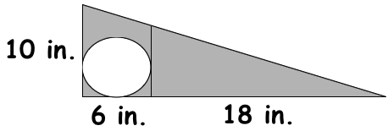 | 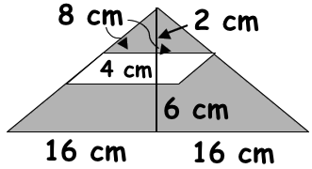
Area of total figure: ___________________  Area of circle: _______________________  Area of shaded region: _________________  : _____________________  Probability: __________________________ | Area of total figure: ___________________  Area of parallelogram: __________________  Area of shaded region: _________________  : _____________________  Probability: __________________________
Adapted from 8th Grade Math Focus Day 82

