Calculator INACTIVE | Problem 1 | Problem 2 | Gridded Response
Monday | Divide 384 by 4. | When you think of the word ‘operations’ in math what should that make you think of? | Problem 1  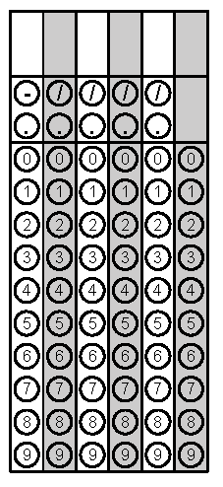
Tuesday | Simplify the Expression:  5y² + 3y – y + 2 | How many cubes with side length $\frac{1}{3}$ cm will fit inside this shape?  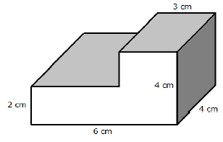 | Problem 2
Wednesday | Solve. Write your answer as an improper fraction.  $3\frac{3}{4}+ 5 \frac{4}{5}$ = | What is the order of operations?  What does it mean to combine like terms? | Problem 1
Thursday | According to the histogram, how many students scored an 80 or higher?  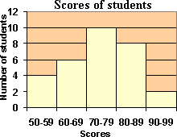 | Write an expression for the following situation and solve.  In the first quarter of a football game, Cam gained 15 yards, lost 2 yards, gained 6 yards, gained 2 yards, and then lost 4 yards. | Problem 1
Friday | Place the following numbers in ascending order and then grid in the greatest value.  $$\frac{18}{5}, 3\frac{2}{3}, 3.65$$ | Mary Beth thinks that -500 is a lot, Eric says that it is not a lot. What do you think and why? | Problem 1

