Calculator INACTIVE | Problem 1 | Problem 2 | Gridded Response
Monday | Divide 384 by 4. | When you think of the word ‘mathematics’ what does it make you think of? | Problem 1  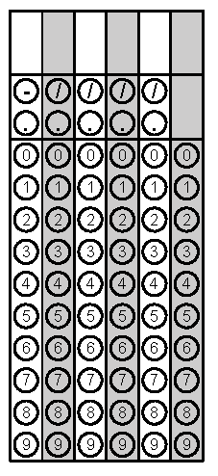
Tuesday | Simplify the Expression:  5y² + 3y – y + 2 | Coffee Beans To Go wants to make sure there is the same number of bags of coffee that show in the front of their shelves. If their top shelf holds 12 bags, second shelf holds 32 bags, and bottom shelf holds 28 bags, how many bags should the employees make visible in the front row? | Problem 2
Wednesday | Solve. Write your answer as an improper fraction.  $3\frac{3}{4}+ 5 \frac{4}{5}$ = | What is the order of operations?  What does it mean to combine like terms? | Problem 1
Thursday | Tony needs 2 pounds of ground beef for his recipe. If 3 pounds cost $15.75, how much will 2 pounds cost? | Write an expression for the following situation and solve.  In the first quarter of a football game, Cam gained 15 yards, lost 2 yards, gained 6 yards, gained 2 yards, and then lost 4 yards. | Problem 1
Friday | Place the following numbers in ascending order and then grid in the greatest value.  $$\frac{18}{5}, 3\frac{2}{3}, 3.65$$ | Mary Beth thinks that -500 is a lot, Eric says that it is not a lot. What do you think and why? | Problem 1

