 | Problem 1 | Problem 2 | Gridded Response
Monday | Subtract:  8 – (-7) | Find 20% of 58. | Problem 1  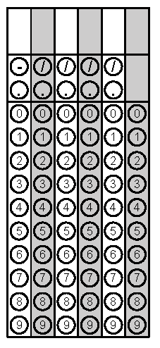
Tuesday | Find the LCM of 16 and 28. | If you borrow 3 dollars for candy 5 days in a row, how much money do you owe? Write as an integer. | Problem 2
Wednesday | If you pay 4 dollars for lunch 3 days in a row and your mom gives you $9.75, how much money do you still need to pay for the lunches? | Solve  $\frac{7}{8}= \frac{x}{72}$ | Problem 1
Thursday | Solve.  3³ + 56 ÷ (11 - 3) | - What is the opposite of 9?  - What is the opposite of the opposite of 9?  - What is the opposite of the opposite of the opposite of 9? | Problem 1
Friday | During a 5-day period, the stock market went down every day. At the end of the period, the stock market index had changed -30 points. What was the average change in the index per day?  A -2 points  B -4 points  C -6 points  D -10 points | Evaluate the following expression:  $$\left|5-(-12)\right|—\left|- 15-(-4)\right|$$ | Problem 2

