 | Problem 1 | Problem 2 | Gridded Response
Monday | Simplify the following expressions:  a) 3(x - 7) =  b) -6(3y + 7) = | Melissa found a shirt on sale for 25% off of $24.99. How much will she pay for the shirt after the discount? Write you answer as a decimal to two places. | Problem 2  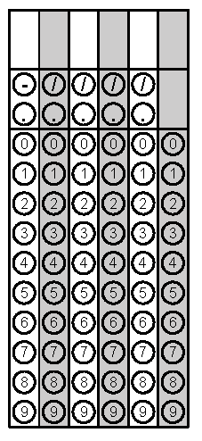
Tuesday | Simplify:  x² + 6x + 3(5x² - 4) + 15 | Joshua is making cookies for his teacher. He wants to make 2 ½ batches. If the recipe calls for 2 ¼ cups of flour for one batch, how much flour will he need to use for 2 ½ batches? | Problem 2
Wednesday | A newspaper reports these changes in the price of a stock over four days:  $\frac{-5}{8}, \frac{9}{8}, \frac{3}{8}, \frac{-1}{8}$  What is the net change in price? | Tony bought 3 boxes of cereal for $3.98 each, 1 bunch of bananas for $2.75, 1 gallon of milk for $3.49, and 2 loaves of bread for $1.99 each. How much did he spend at the store? | Problem 2
Thursday | Evaluate the following expressions if A= -2, B=6, and C= -5  - AC + B =  - C⁰ + $\frac{B}{A}$ = | Evaluate:  3x – 2 – (x + 3) when x = -4 | Problem 1 Part 2
Friday | Simplify.  - 3 + (-9) =  - (-5) – (-9) =  - 6(-11) =  - 56 ÷ (-8) = | Solve for the missing value.  98 ÷ (x) = (-14) | Problem 1D

