 | Problem 1 | Problem 2 | Gridded Response
Monday | Round the following to the nearest tenth:  - 58.629 =  - 3.25 =  - 8.3498 = | Convert the following to improper fractions:  - 3$\frac{5}{12}$ =  - 5$\frac{2}{5}$ =  - 2$\frac{3}{15}$ = | Problem 2C  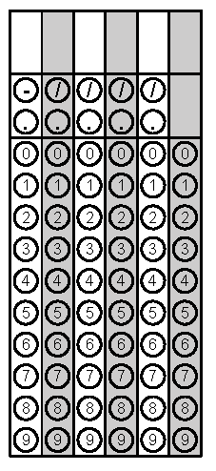
Tuesday | Mrs. Rice kept track of the amount of students that completed their homework last night. Which class had the highest completion rate? Order the classes from least to greatest.  1st Core: 19/25  2nd Core: 0.75  3rd Core: 82%  4th Core: 23/28 | What is the additive inverse of 5? | Problem 2
Wednesday | Solve.  85 + (-112) =  65 - (132) = | Katie’s cell phone bill is automatically deducting $49 from her bank account every month. As an integer, how much will the deductions total for the year? | Problem 2
Thursday | Simplify:  -14.5863 ÷ 0.9 | We want to buy some material for a costume for Halloween. If the fabric we want to buy costs $1.55 per yard and we need 2.75 yards, and we only have $5.00, do we have enough money to buy the fabric? | Problem 1
Friday | Maria makes $8.25 an hour working at the local fast food restaurant. What will her gross pay be for the week if she works 9.5 hours? If she wants to buy a stereo for $75.00. Does she owe money (negative) or have extra money (positive)? | Solve.  - $\frac{1}{3}-\frac{5}{6}$ =  - 3 $\frac{1}{2}$ + (-$\frac{5}{7}$) = | Problem 2B

