 | Problem 1 | Problem 2 | Gridded Response
Monday | Solve.  a. $2\frac{3}{5} × -15=$  b. $-2\frac{5}{8}÷-\frac{1}{8}=$ | For every 5 cups of flour, 2 cups of sugar are needed to make cookies.  - What is the ratio of flour to sugar? Write your answer as a fraction.  - Using the same ratio, how many cups of sugar are needed for 8 cups of flour? | Problem 2A  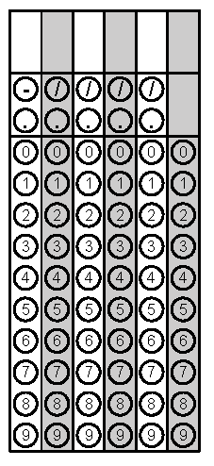
Tuesday | James has 17 cookies. He wants to share them with his two best friends. How many cookies will James and each of his friends get? | Solve:  a) 6 + (-11)  b) -2 + (-8)  c) -4 + 12 | Problem 1
Wednesday | A hiking trail is 8 $\frac{2}{5}$ miles long. It has 3 exercise stations, spaced evenly along the trail. What is the distance between each exercise station? | The elevator in a parking deck goes 25 feet below ground level. What integer represents this depth in feet? | Problem 2
Thursday | A box of cereal contains  24$\frac{1}{2}$ ounces of cereal. If a bowl holds 2$\frac{4}{5}$ ounces of cereal, how many bowls of cereal are in one box? | What is the greatest common factor of 12 and 18?  What is the least common multiple of 12 and 18? | Problem 1
Friday | A one-half gallon carton of milk costs $1.99. A one-gallon carton of milk costs $3.49. How much money would you save if you bought a one-gallon carton instead of 2 one-half gallon cartons? | The mathematics club wants to divide the boys and girls into the greatest number of teams possible. Each team will have the same number of boys and the same number of girls. There are 90 boys and 72 girls. How many boys and girls will be on each team? | Problem 1

