 | Problem 1 | Problem 2 | Gridded Response
Monday | Find the following absolute values and put the resulting integers in descending order.  $$\left|-5\right|, \left|8\right|, \left|0\right|, \left|-12\right|$$ | Solve.  + 3( ) – 12  when = 5 | Problem 2  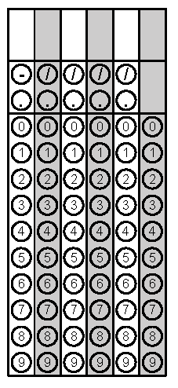
Tuesday | Simplify:  5x² + 2x - 3(6x² - 1) + 9 | Renee received $35.75 for selling 55 candy bars for a school fundraiser. At what rate was Renee selling each candy bar? | Problem 2
Wednesday | Tyra can type 275 words in 5 minutes. Nick can type 372 words in 6 minutes. Which one types at the fastest rate per minute? | Coach Jones bought 14 shirts for $210 for the basketball team.  - What was the unit rate of the shirts?  - The unit rate for shorts was $2.50 less than the unit rate for shirts. Coach Jenson bought the same number of shorts as shirts to complete each uniform. What was the total cost of the uniforms for the team? | Problem 2A
Thursday | A person made 3 blankets. Each blanket used 312 inches of ribbon for the border. How many yards of ribbon did the person use for all three blankets? | Which sentence represents this equation?  3(x + 2) = 15  A. Three times a number plus two is 15.  B. A number minus two times three is 15.  C. Three times the quantity of a number plus two is 15.  D. Three times a number is 15 plus two. | Problem 1
Friday | The school cafeteria makes pudding every Wednesday. Each box of pudding mix uses 3 cups of milk. How many quarts of milk will be used to make 76 boxes of pudding mix? | Solve: 4x + 5 = 33 | Problem 2

