 | Problem 1 | Problem 2 | Gridded Response
Monday | Solve:  $\frac{3}{4}\left(8x+4\right)= -2x+35$ | Solve:  x³ = 125 | Problem 2  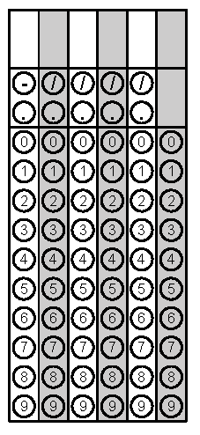
Tuesday | Solve:  x² = $\frac{49}{81}$ | Approximate the value of $\sqrt{18}$ to the nearest tenth. | Problem 2
Wednesday | Circle the irrational number:  $$-\frac{25}{5} \sqrt[3]{27} \frac{13}{5} \sqrt{32}$$ | Solve:  x³ = $\frac{8}{343}$ | Problem 2
Thursday | Put the values in ascending order.  $$-\frac{25}{5} \sqrt[3]{27} \frac{13}{5} \sqrt{32}$$ | A garden has an area of 144 square feet. If you want to edge the garden with 1 foot pavers that cost $2.35 each, how much will it cost you? | Problem 2
Friday | Convert the following decimal to a fraction in simplest form.  $0.2\overline{7}$ | Are repeating decimals rational or irrational numbers? Explain. | Problem 1

