 | Problem 1 | Problem 2 | Gridded Response
Monday | What do these symbols mean?  - >  - <  - ≥  - ≤ | Simplify the expression. Grid in the coefficient of x.  x−7x−(−2x) | Problem 2  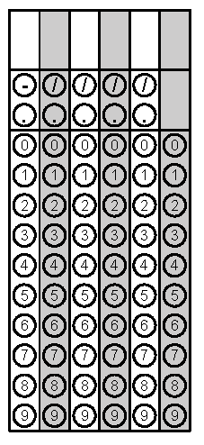
Tuesday | Write an inequality to represent each situation:  A. Abby has less than $20 in the bank.  B. Abby has at least $20 in the bank.  C. Abby has more than $20 in the bank.  D. Abby has at most $20 in the bank | Three children took toys from a box. The first child took 8 toys. The second child took half of the remaining toys. The third child took the last 5 toys. How many toys were in the box at the beginning? | Problem 2
Wednesday | Allan has $25 dollars to spend. He spent $12.89, including tax, to buy a new DVD. He needs to save $5.00 but he wants to buy a snack. If a candy bar costs $0.75 per bar, what is the maximum number of candy bars that Allan can buy? | Solve.  4 – x > 8.6 | Problem 1
Thursday | Nicole has at most $50 to spend on clothes. She wants to buy a pair of jeans for $18 dollars and spend the rest on t-shirts. Each t-shirt costs $9. Write and solve an inequality for the number of t-shirts she can purchase. | Lee picks apples at an orchard. He earns $6.25 for each hour he works and $3.75 for each bushel he picks. His goal is to earn at least $150 this week. Write an inequality that will help Howard determine the number of hours (h) and bushels (b) he needs to reach his goal? | Problem 1
Friday | A country store buys pecans in bulk and then sells them by the pound. If the store owner spends $235 on pecans and then sells them for $13.50 per pound, how many pounds must the owner sell to make a profit? Round to the nearest whole pound. | The band ordered 25 pizzas to be divided equally among 90 participants. How much pizza will each participant get? | Problem 1

