 | Problem 1 | Problem 2 | Gridded Response
Monday | Antonio and Maria are building scale models of different vehicles for a class project. They just completed a 5 inch long model of a car that is 20 feet in length. If they use the same scale, what will be the length of a scale model of a truck that is 38 feet long? | A pizza shop uses ½ ounce of pepperoni for every $\frac{1}{3}$ of a large pizza. How much pepperoni does one large pizza have? | Problem 2  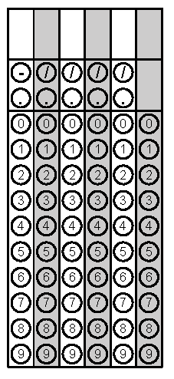
Tuesday | Emily shows the scale drawing of her room below. If each 2 inches on the scale drawing equals 5 ft, what is the actual perimeter of Julie’s room?  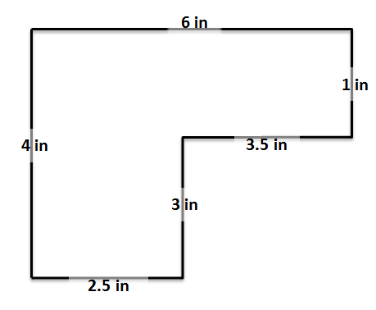 | The distance between two cities on a map is 5 inches. The scale on the map is 2 inches = 150 miles. What is the actual distance between the two cities? | Problem 1
Wednesday | Tom started with a full tank of gasoline and drove his car 331$\frac{1}{4}$ miles. When Tom refilled the gas tank, he had to add 12.5 gallons of gasoline. What is the fuel efficiency, in miles per gallon, of Tom’s car? Round answer to the nearest tenth. | If the rectangle below is enlarged using a scale factor of 2.5, what will be the perimeter and area of the new rectangle?  3 in.  12 in. | Problem 2 - Area
Thursday | A painter used $\frac{3}{4}$ gallons of paint to paint ½ of a room. At this same rate, how many gallons will it take to paint the whole room? | For every 10 apples gathered from trees in an orchard, there are 8 apples that are good to sell. Write an equation that determines the constant relationship between g, the number of apples gathered, and s, the number of apples good to sell. | Problem 1
Friday | On a park map, the distance from a picnic table to the hiking trail is 3 centimeters. The map uses a scale of 2 cm = 225 meters. What is the actual distance from the picnic table to the hiking trail? | Amanda’s school has a total of 462 seventh grade students. There are 3 technology classes, each with 22 seventh grade students. What is the ratio of seventh grade students taking a technology class to all seventh grade students? | Problem 1

