 | Problem 1 | Problem 2 | Gridded Response
Monday | Mark and his two friend went out to dinner. They agreed to pay equal parts of the bill. If Mark pays $13.72, what was the total bill? | On Monday, Angie made 9 out of the 15 basketball shots she attempted. At this rate, how many shots will Angie make on Tuesday, if she attempts 25 basketball shots? | Problem 2  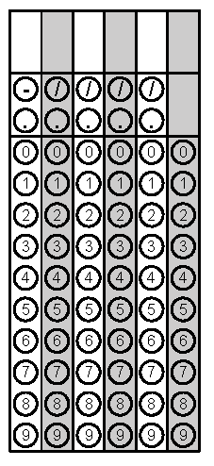
Tuesday | If $36 represents 75% of the amount of money collected in one hour, what was the total amount of money collected in that hour? | Aliyah had a coupon for a 20% discount off the regular price of a pair of shoes at a shoe store. The regular price of the shoes she bought was $49. What was the discounted price of the shoes, not including tax? | Problem 2
Wednesday | Find 15% of 60. | All swimsuits at a clothing store were marked down 20% on July 31. On September 7, all remaining swimsuits were marked down an additional 30%. If a swimsuit was originally $34, how much does it cost after October 1? | Problem 2
Thursday | At a certain store, 60 television sets were sold in June. The manager at the store wants to encourage the sales team to sell more TVs by giving all the sales team members a bonus if the number of TVs sold increases by 20% in July. How many TVs must the sales team sell in July to receive the bonus? Justify the solution. | Elijah buys a meal that costs $5.35. He is charged 7.5% tax. Calculate the amount of tax, t, Elijah will have to pay. Round to the nearest cent. | Problem 1
Friday | The manufacturer's price for running shoes is $12.50. A shoe store that bought the shoes sells them for $60.95. Approximately what was the percent of increase in the price of the shoes? | Jeremiah took a math test and got 42 correct and 8 incorrect answers. What was the percentage of correct answers? | Problem 2

