 | Problem 1 | Problem 2 | Gridded Response
Monday | Circle the irrational number.  $$\sqrt{169} \frac{17}{2} {\left(\frac{3}{4}\right)}^{3} \sqrt{120}$$ | A basketball player has a 60% field goal average. If he attempts 35 field goals in the next game, how many should he expect to make? | Problem 2  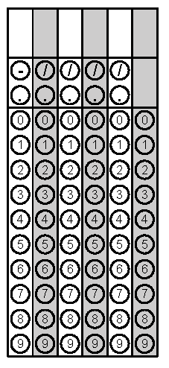
Tuesday | Determine the probability of getting a 100% on a quiz that has five true/false questions. Each question has 2 answer choices. Give your answer in simplest fraction form. | Which of the following is not an integer?  $$\sqrt{\frac{81}{9}} -\frac{56}{3} {\left(-\frac{35}{5}\right)}^{2}$$ | Problem 1
Wednesday | Convert the following repeating decimal to a fraction.  $$5.\overline{24}$$ | Jordan, Xavier, and Alexis are in line for lunch. How many different ways can they line up? Use a visual model to support your answers. | Problem 2
Thursday | How many ways could the 4 students, Andy, Breanna, Cyndi, and Dan come in 1st, 2nd, 3rd, and 4th place? | Estimate the square root of 50 to the nearest tenth. | Problem 1
Friday | Solve.  $$\frac{3}{4}\left(x-16\right)+ 4= \frac{1}{6}x-13$$ | There are 5 red, 10 green, 4 yellow and 6 white golf balls in Connie’s bag. When she reaches in her bag, what is the probability that she grabs 1 yellow ball replaces it and then grabs one red ball? | Problem 2

