 | Problem 1 | Problem 2 | Gridded Response
Monday | Kathleen is shopping for an outfit to wear to her birthday party. She has $50 to spend. She finds a dress for $65 and she has a 25% off coupon. Does she have enough money to buy the dress? | Peter had $3000. He deposited 60% of the money into a simple interest account. The account has a 5% annual interest rate. How much interest has he earned on this deposit at the end of six months? | Problem 2  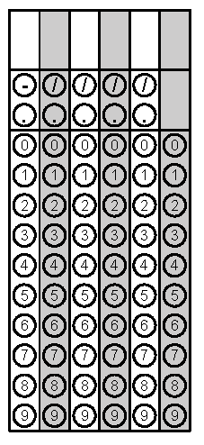
Tuesday | Jaylen buys 5 pounds of strawberries from a farmer for $8.50. He then sells the strawberries for $15. What percent mark-up does Jaylen use for his strawberries? Round to the nearest tenth of a percent. | The price of a pair of jeans decreases from $25 to $15. What is the approximate percentage of decrease? | Problem 1
Wednesday | Solve.  - 10% of 18  - 25% of 58  - 35% of 176 | A stereo that normally sells for $140 is on sale for $105. By what percent has the price of the stereo been reduced? | Problem 1B
Thursday | Chloe makes a base salary of $1,200 each month. She also earns 1.5% commission on her sales. If she sold a $240,000 house this month, how much will her pay check be? | What is the total cost of a $57 purchase after applying a sales tax rate of 8%? | Problem 2
Friday | Jerry buys $185 worth of clothes for his new job. If he has to pay 8.5% sales tax, how much does he owe the cashier? Round to the nearest hundredth. | In art class, Ava is mixing paint. The paint mixture is 3 parts red and 5 parts blue. What percent of the paint is blue? | Problem 1

