 | Problem 1 | Problem 2 | Gridded Response
Monday | If two pounds of pecans costs $6.40 and 5 pounds cost $16.50, is the cost of almonds proportional to the weight? | The price of a candy bar is $1.35. If this is five cents less than quadrupole the price ten years ago, how much did the candy bar cost ten years ago? | Problem 2  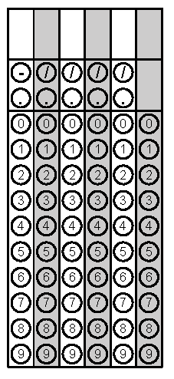
Tuesday | Evaluate the following expression if x = -5.  $$3x^{3}+ 5x^{2}- 4x$$ | If Sandi’s chicken salad wrap has 430 calories per serving and the package says the entire wrap is equal to 1.5 servings, how many calories are in her entire lunch? | Problem 1
Wednesday | If eighteen more than the square of a number is 307, what’s the number? | David just got a dog. The food the dog eats says to feed the dog 1$\frac{3}{8}$ cups of food per day. If he wants to feed his dog twice a day, how much food should he give his dog each time? | Problem 1
Thursday | Taylor received an 85, 98, 94, and 89 on her past 4 quizzes. If she wants to have an average higher than 92, what does she have to earn on her fifth quiz? | Find $\sqrt[3]{512}$. | Problem 2
Friday | Anthony needs a new suit. He has a 20% off coupon that will be applied before a tax of 7.5% is applied to his total. How much will he end up paying for a $275 suit? Round to the nearest hundredth. | Is $\frac{2}{3}$ rational or irrational? Explain your answer. | Problem 1

