 | Problem 1 | Problem 2 | Gridded Response
Monday | Aarav put $2500 in a savings account that earns 3% interest annually for 5 years. James put $2050 in an account that earns 4% interest annually for 6 years. Who has more money in their account when they take their money out? | A box has p sheets of writing paper and three-fourths as many envelopes. If there is a total of 448 sheets of paper and envelopes, how many envelopes are there? | Problem 2  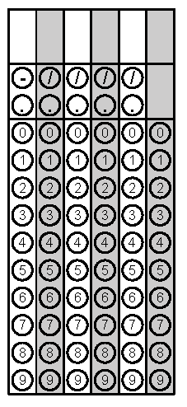
Tuesday | I estimated my bag of chips would have 20 chips, but it really had 16. What was my percent error? Round to the nearest whole percent. | Krishna sells lemonade for $0.50 per cup. She buys her cups for $0.03 each, and it costs her $0.12 to make each cup of lemonade. If she sells 18 cups, how much money will she make? | Problem 2
Wednesday | First quarter Perry earned a 79 in math. Second quarter Perry earned a 92 in math. What was his percent increase from first quarter to second quarter? Round to the nearest tenth. | Hannah is building a book shelf. The wood she is using is sold in sections that are 6 feet long and 18 inches wide. All of the boards Hannah needs will be 18 inches wide. She needs 4 boards that each measure 36 inches long. She needs 3 boards that each measure 52 inches long. What is the minimum number of 6 foot sections of wood Hannah will need to make the book shelf? | Problem 1
Thursday | Kennedy bought a sweater that originally cost $25. It was on sale for 15% off the original price. What is the sale price of the sweater? | A bicycle normally sells for $425. The bicycle was discounted 40% for a sale. After the sale was over, the new price of the bicycle was 30% higher than the sale price. What was the new price of the bicycle? Round to the nearest cent. | Problem 1
Friday | Mr. Barber works as a real estate agent. He gets a 4% commission when he sells a house. He sold a house for $210,000. How much commission did Mr. Barber earn? | An account earned $286.54 in simple interest over 5 years and 9 months. There were no deposits or withdraws on the account. The interest rate is 2.5%. Which was the principal for this account? | Problem 1

