 | Problem 1 | Problem 2 | Gridded Response
Monday | Find the mean absolute deviation of the following data set:  14.6, 24.2, 19.5, 17.8, 22.6, 21.3 | Solve.  $$\frac{2}{3}\left(6x+9\right)= -5x+4$$ | Problem 2  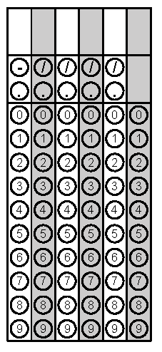
Tuesday | Between what two integers does the $\sqrt{7}$ fall? | Convert $0.58\overline{3}$ to a fraction in simplest terms. | Problem 2
Wednesday | If a number cubed is 216, what is the number? Write an equation to solve for the number. | What is the highest integer solution for this inequality?  $$5x-7< -3x+25$$ | Problem 1
Thursday | Using measures of center and variability discuss what the box plot shows about the age at death between women and men. | The students at a university were surveyed about their satisfaction with the dining hall food on a scale of one to ten, one being the lowest, and ten being the highest. The following box plot was used to show the information gathered. 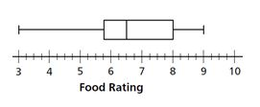What was the lowest rating?  What was the highest rating?  Where did 50% of the data fall?  What is the interquartile range?  Box plot taken from Connected Mathematics 2 Samples and Populations | Problem 2 - Highest Rating
Friday | Plains Middle School is considering the following location for a Grade 7 field trip: science museum, state park, or Ballet Company. The principal wants to survey a sample of students to find which location Grade 7 students would prefer. Do you think the following are good surveys? Why or why not?  - The principal surveys the members of the science club for the sample  - The principal surveys every tenth student to walk into the middle school on a given morning  - The principal surveys a group of randomly-selected Grade 7 girls | Find the slope of the line formed by (-4, 6) and (10, -1). | Problem 2
Questions adapted from Score21 and SchoolNet

