 | Problem 1 | Problem 2 | Gridded Response
Monday | A bag holds 20 balls. Ten of the balls are orange and ten are white. One orange ball has an X on it, and one white ball has an X on it. If a ball is randomly selected from the bag, what is the probability that it has an X on it? | A school has just been built in northern Raleigh. If the school has at most $225,000 to spend on laptops, how many laptops can the school buy if they cost $1400 each? | Problem 1  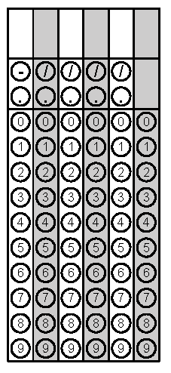
Tuesday | How many possible combinations of two number cubes, numbered 1 through 6, would add up to exactly 7? | Solve.  $6.2 ×3 × -\frac{1}{2}$ | Problem 2
Wednesday | The scores of two basketball teams in 7 games are given below.  Team A: 20, 68, 60, 54, 58, 55, 63  Team B: 52, 62, 54, 71, 49, 54, 22  What is the difference between the mean of Team A and the mean of Team B? | Simplify.  $-2\frac{3}{8}x+2.5- 3\frac{1}{4}$x | Problem 1
Thursday | The data below shows the scores of two groups of ten students on a math quiz and a science quiz.  Math: 72, 92, 88, 67, 54, 58, 64, 76, 65, 72  Science: 84, 78, 56, 89, 54, 68, 75, 78, 84, 60  What is the median of each class? | Kylie is heading to college. She finds out she has to pay $1,250 per credit she takes. If she is taking 15 credits, how much will she owe the college? | Problem 2
Friday | A deli that just opened was giving out free mini sandwiches. A sample of 50 likely customers was surveyed about which sandwich they preferred. The people surveyed included 12 people who said they preferred the roast beef sandwich. Based on this information, how many of the first 150 sandwich orders should the deli predict will be for roast beef? | BWR is having a jeans sale. All jeans are 20% off. If one pair cost $65.52 and the other cost $15.12 on sale, what would have been the total cost before the sale? | Problem 1
Questions adapted from Score21 and SchoolNet

