 | Problem 1 | Problem 2 | Gridded Response
Monday | What is the probability of rolling a 3 followed by a 7 on a six-sided number cube? | On Monday, Alison made 12 out of the 22 basketball shots she attempted. At this rate, how many shots will Alison make on Tuesday, if she attempts 33 basketball shots? | Problem 2  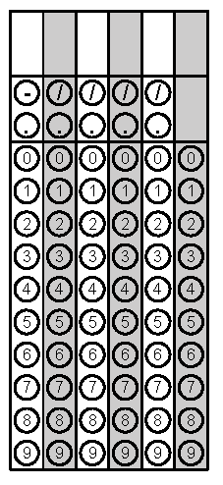
Tuesday | Julissa had a coupon for a 15% discount off the regular price of a pair of shoes at a shoe store. The regular price of the shoes she bought was $39. What was the discounted price of the shoes, not including tax? | When you roll a number cube two times, what is the probability of both numbers being even? Both numbers being odd? One odd and one even? | Problem 1
Wednesday | How many possible outfits can Clarise put together with her 5 shirts, 3 pairs of shorts, and 2 pairs of shoes? | Jordan is at a coffee shop. She has three different size drinks (small, medium, and large) to choose from and 4 different kinds of coffee (Light roast, medium roast, dark roast, and espresso). What is the probability of Jordan choosing a medium size light roast coffee? | Problem 1
Thursday | All swimsuits at a clothing store were marked down 30% on July 10. On August 1, all remaining swimsuits were marked down an additional 20%. If a swimsuit was originally $18, how much does it cost after August 1? | If Mary chooses a point in the square, what is the probability that it is not in the circle? | Problem 2
Friday | Determine all possible outfit combinations Clive can put together if he has 4 shirts that are blue, black, brown, and green and 3 pairs of pants that are jeans, khaki, and dress pants. | The manufacturer's price for a tent is $28.50. A camping store that bought the tents sells them for $40.76. Approximately what was the percent of increase in the price of the tents? | Problem 2
Questions adapted from Score21 and SchoolNet

