 | Problem 1 | Problem 2 | Gridded Response
Monday | If two pounds of almonds costs $8.20 and 5 pounds cost $19.75, is the cost of almonds proportional to the weight? | The price of a candy bar is $1.53. If this is three cents more than triple the price ten years ago, how much did the candy bar cost ten years ago? | Problem 2  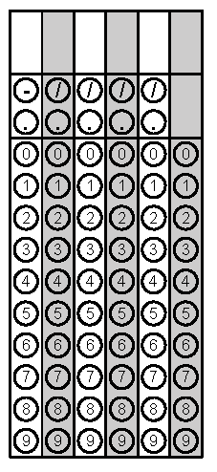
Tuesday | Evaluate the following expression if x = -8.  $$2x^{3}- 3x^{2}+ 9x$$ | If Sandi’s chicken salad wrap has 570 calories per serving and the package says the entire wrap is equal to 2.5 servings, how many calories are in her entire lunch? | Problem 1
Wednesday | If fourteen less than the square of a number is 182, what’s the number? | Aaron just got a dog. The food the dog eats says to feed the dog 1$\frac{7}{8}$ cups of food per day. If he wants to feed his dog twice a day, how much food should he give his dog each time? | Problem 1
Thursday | Bella received an 89, 92, 94, and 90 on her past 4 quizzes. If she wants to have an average higher than 93, what does she have to earn on her fifth quiz? | Kat’s age is 4 more than twice Rob’s age. How old is Kat if Rob is 30 years old? | Problem 2
Friday | Armin needs a new suit. He has a 25% off coupon that will be applied before a tax of 7.5% is applied to his total. How much will he end up paying for a $325 suit? Round to the nearest hundredth. | Is $-\frac{54}{99}$ an integer or not? Explain your answer. | Problem 1
Questions adapted from Score21 and SchoolNet

