 | Problem 1 | Problem 2 | Gridded Response
Monday | If a square room with an area of 289 square feet is tiled using square tiles with a side length of 1 foot, how many tiles line each wall of the room? | A scale drawing of a playground has dimensions of 3 in by 4.5 in. If the scale to the actual playground is 1 in = 40 ft, find the area of the actual playground in square feet. | Problem 1  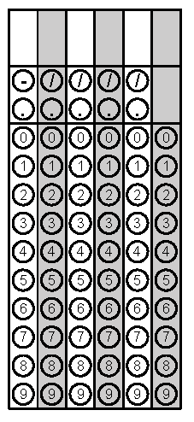
Tuesday | If the circumference of a circle is 43.96 cm, find the area of the circle. | Marlon is over-seeding his lawn to fill in bare spots. If his yard is 60 feet by 84 feet and a bag of grass seed will cover 1,500 square feet, how many bags should Marlon buy to reseed his lawn? | Problem 1
Wednesday | Find the area of a circle with a diameter of 4.5 cm. Round to the nearest tenth. | A rectangular prism has how many faces? | Problem 1
Thursday | Dana draws a scale drawing of a tree using the following scale:  3 cm tall in drawing = 5 meters in real life  If Dana draws a tree that is 6.3 cm tall, what would be the height of the actual tree? | Find the area of the shaded region below if the length and width of the white rectangle is 6 in by 11 in and the length and width of the outer rectangle is 13 in by 28 in. | Problem 2
Friday | Find the area of a trapezoid with height of 7 in and bases of length 3.5 in and 5.4 in. | Find the complement of an angle with a measure of 47.3˚. | Problem 1

