 | Problem 1 | Problem 2 | Gridded Response
Monday | What shape is the base of a triangular prism?  A cylinder? | Find the measure of each base angle of an isosceles triangle with a vertex angle of 120°. | Problem 2  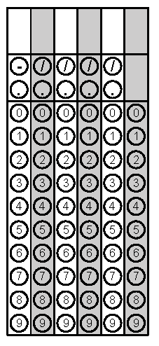
Tuesday | Find the surface area of a cube with a side length of 6.5 cm. | A hallway in Phil’s house is rectangular and measures 12 feet by 4 feet. Will a circular rug with a radius of 3 feet fit in his hallway? | Problem 1
Wednesday | Find the area of the composite figure below if the square has side lengths of 4.5 feet and the triangle has a height of 3.2 feet. | Find the volume of a cylinder with diameter of 8 cm and height of 5.5 cm. | Problem 2
Thursday | Find the surface area of a packing box shaped as a rectangular prism with a width of 8 in, height of 12 in, and length of 9 in. | What is the maximum volume of sand that can fit inside a cylinder with radius of 52.5 feet and height of 9.2 feet? Round the nearest hundredth. | Problem 1
Friday | Find the volume of a cereal box with dimensions of 32cm, 21cm and 9cm. | If a triangle with a height of 5 feet has an area of 8 square feet, find the length of the base. | Problem 2

