 | Problem 1 | Problem 2 | Gridded Response
Monday | The surface area of a cube is 96 in². What is the volume of the cube? | Natasha stands 5.5 feet tall and has a shadow that measures 3 feet long. At the same time, a tree next to Natasha has a shadow that measures 12 feet long. How tall is the tree? | Problem 1  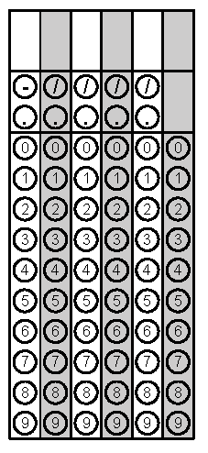
Tuesday | A company sells snack mix in a cylindrical can. The can has a 5-inch diameter and holds approximately 157 in³ of snack mix when it is completely full. How tall, to the nearest inch, is the can? | Huong covered the box below with sticky-backed decorating paper. The paper costs 3¢ per square inch. How much money will Huong need to spend on paper?  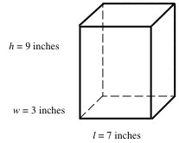 | Problem 2
Wednesday | Jack is making 4 cylindrical wax candles. If he plans to make candles with a diameter of 7 cm and a height of 12 cm, approximately how many cubic centimeters of wax will Jack need to make the candles? | 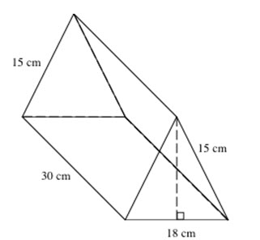  If the volume of the triangular prism is 3,240 cm³, what is the height of the triangle? Explain. | Problem 2
Thursday | 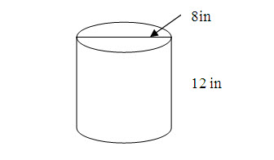  What is the volume of the cylinder? | A sphere is shown below.  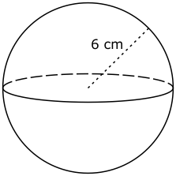  What is the approximate volume of the sphere? | Problem 1
Friday | What is the approximate volume of the cone below?  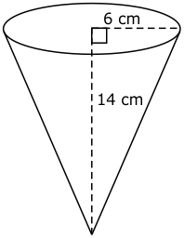 | Danny needs to buy sand for this box. He wants to nearly fill the box, leaving only 6 inches empty at the top. How much sand does Danny need? | Problem 2
Questions adapted from Score21 and SchoolNet

