 | Problem 1 | Problem 2 | Gridded Response
Monday | James wanted to plant pansies in his new planter. He wondered how much potting soil he should buy to fill it. Use the measurements in the diagram below to determine the planter’s volume.  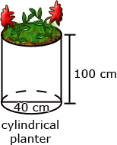 | A soup bowl is in the shape of a hemisphere with a diameter of 10 cm. What is the approximate maximum volume of soup that the bowl can hold? | Problem 1  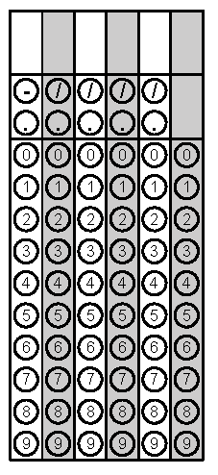
Tuesday | Evaluate ${\left[\frac{2}{7}\left(g^{3}-1\right)\right]}^{4}$ if $g=2$ | 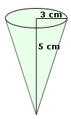  How much yogurt is needed to fill the cone to the right? Express your answers in terms of Pi. | Problem 2
Wednesday | Determine the value of the following:  - $2^{4}$  - ${(-3)}^{2}$  - $-3^{2}$  - $n^{4}$ for n = -5  - $n^{3}$ for n = -5 | Laura made two spherical pillows. Each pillow had a radius of 6 inches. Approximately what is the total volume of space Laura had to fill with stuffing? | Problem 1a
Thursday | The volume of a cone is 25$π$ cubic inches. If the radius is 5 inches, what is the height of the cone? | Explain why the value of -3⁰ is negative but the value of (-3)⁰ is positive. | Problem 1
Friday | If 7⁻² is raised to the power of 3, what is the result? | What is the approximate area of the shaded region in the figure below? Round to the nearest hundredth.  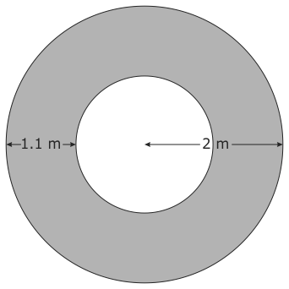 | Problem 1
Questions adapted from Score21 and SchoolNet

