QUIZ #2 Name: _______________________Date:__________Period:____

***Find the unit rates for each given situation.***

1.__________________

2.__________________

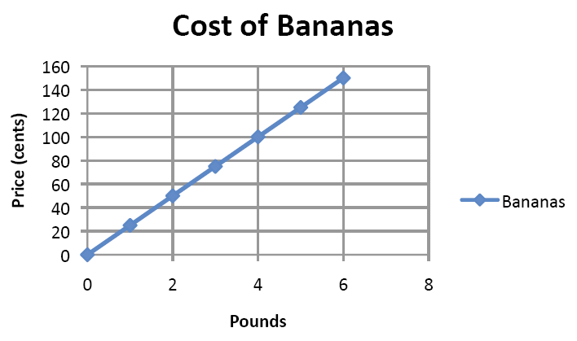1. Gabrielle bikes 6 miles in  an hour. 2. gallon of paint coversof a wall 

***Using the graph below, answer questions 3 and 4.***

3. What is the constant of proportionality?

4. What does (0, 0) represent in this situation?

***Create a graph for each table below then determine if the sets are proportional. Explain how you used your graph to get your conclusion.***

6.

|  |  |  |  |  |
| --- | --- | --- | --- | --- |
| **X** | **1.5** | **3** | **3.75** | **6** |
| **Y** | **1** | **1.5** | **2.5** | **4** |

5.

|  |  |  |  |  |
| --- | --- | --- | --- | --- |
| **a** | **1** | **3** | **5** | **7** |
| **b** | **2** | **4** | **6** | **8** |





Proportional? __________ Proportional? __________

Explain:____________________________________ Explain:___________________________________

____________________________________________ ____________________________________________

***In questions 7 and 8 use the tables to find ratios and determine if the sets are proportional to each other. Explain how you used your tables to get your conclusion.***

***If the table represents a proportional relationship, write an equation for it.***

8. x = number of minutes, y = cost in dollars

|  |  |  |  |  |  |
| --- | --- | --- | --- | --- | --- |
| x | **0** | **3** | **4** | **8** | **12** |
| y | **2** | **5** | **6** | **10** | **14** |

Proportional?________

Explain and show proof:

Equation: _____________

(if necessary)

7. c = Number of chocolates, m = Number of minutes

|  |  |  |  |  |
| --- | --- | --- | --- | --- |
| c | **2** | **4** | **6** | **8** |
| m | **4** | **8** | **12** | **16** |

Proportional? _______

Explain and show proof:

Equation: _____________

(if necessary)

***Determine if the ratios are proportional. Write “yes” or “no” and justify.***

9.  and  ________ 10.  and  ________

**Determine which is the “better buy” by finding the unit price of each and comparing them.**

11. sodas: 12 for $2.89 or 24 for $6.00 11.____________________

12. socks: 3 pairs for $10 or 8 pairs for $16.99 12.____________________

**Solve each proportion for the variable, using the method of your choice.**

13.___________

14.___________

13.  =  14.  = 

**For each word problem, write a proportion and then solve it to find the answer. Label your final answers.**

15.______________

16.______________

17.______________

18.______________

19.______________

20.______________

15. A recipe calls for 2 eggs to make 10 pancakes. How many eggs are

needed to make 35 pancakes?

16. Sandra drove 126.2 miles in 2 hours at a constant speed. How long

would it take her to drive 189.3 miles at the same speed?

17. Eight oranges cost $1.00. How much will 5 dozen oranges cost?

18. In order to determine her pulse rate, June’s nurse counted 18 beats

in her pulse in 15 seconds. At this rate, how many beats would she

have in 60 seconds?

19. Ed earned $112 for 8 hours of work. At this rate, how much will he

earn for 40 hours of work?

20. Mary is preparing for her college entrance exams. In a practice test,

she answered 12 problems in 30 minutes. At this rate, how many

questions can she expect to answer in 150 minutes?