Reflection HW Name _______________________________________

Reflect each figure as described. Write the coordinates of the figure’s image after it has been reflected.

1. Reflect XYZ across the x-axis. X (-3, -2), Y (-5, 0), Z (1, 3)

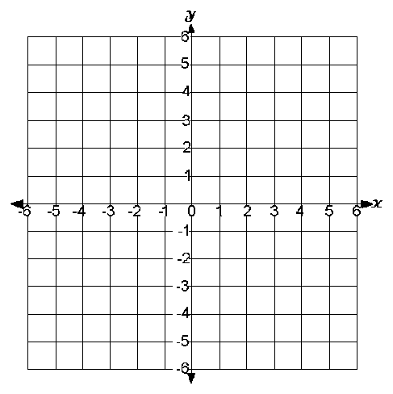
X´ ( , )

Y´ ( , )

Z´ ( , )

2. Reflect XYZ across the y-axis. X (3, -4), Y (0, 4), Z (1, -2)

X´ ( , )

Y´ ( , )

Z´ ( , )

3. Figure FGHJ has the following coordinates.
F (-4 , 2) G (-4 , 4) H (1 , 4) J (-1 , -2)

Give the coordinates of the image of figure FGHJ if it is reflected across the:
a) y-axis b) x-axis

F´ ( , ) G´ ( , ) F´ ( , ) G´ ( , )

H´ ( , ) J´ ( , ) H´ ( , ) J´ ( , )

