Stained Glass Window Project Name ________________________
You must determine 12 equations of lines with the following criteria:

Group A: 3 lines must have  - 0 slope  - At least one line must be above the x-axis  - At least one line must be below the x-axis  - The equations may NOT equal ZERO and MUST be simplified | Group B: 3 lines must have:  - No/undefined slope  - At least one line must be to the left of the y-axis  - At least one line must be to the right of the y-axis  - The equations may NOT equal ZERO and MUST be simplified
Group C: 3 lines must have:  - Positive, yet different slopes  - Different y-intercepts, but one must go through the origin  - Slopes can not all be whole numbers | Group D: 3 lines must have:  - Negative, yet different slopes  - Different y-intercepts, but one must go through the origin  - Slopes can not all be integers

Write each of the equations on the lines below. Identify the slope and y-intercept (write as a coordinate point) for each equation. Then graph these equations on the coordinate plane provided and follow instructions on paper.
Group A
Equation: _____________ Equation: ____________ Equation: _____________
Slope = __________ Slope = __________ Slope = __________
Y-intercept = ______ Y-intercept = ______ Y-intercept = ______
Group B

Equation: _____________ Equation: _____________ Equation: _____________
Slope = __________ Slope = __________ Slope = __________
Y-intercept = ______ Y-intercept = ______ Y-intercept = ______
Group C

Equation: _____________ Equation: _____________ Equation: _____________
Slope = __________ Slope = __________ Slope = __________
Y-intercept = ______ Y-intercept = ______ Y-intercept = ______
Group D

Equation: _____________ Equation: _____________ Equation: _____________
Slope = __________ Slope = __________ Slope = __________
Y-intercept = ______ Y-intercept = ______ Y-intercept = ______

Stained Glass Window Project Name __________________________
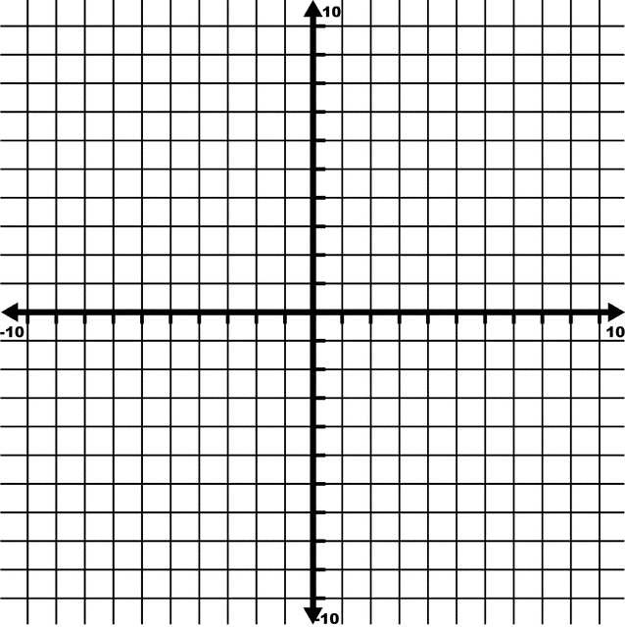
On the coordinate plane below, graph the linear equations you created. Use the slope and y-intercept you listed for each equation to graph it. Write the equation neatly and legibly on each line that you graph. When you are finished graphing the equations, use a dark-colored marker and a straight edge to trace over the lines, then color each section to create your stained glass window.

Stained Glass Window Project Rubric Name _____________________
Objective | Rocked it | Most of the Time | Needs development
Group A  - Equations are written in the correct form (and simplified)  - Equations meet criteria  - Slope is correctly identified  - Y-intercept is correctly identified as a coordinate pair | 4 | 3 2 | 1 0
Group B  - Equations are written in the correct form (and simplified)  - Equations meet criteria  - Slope is correctly identified  - Y-intercept is correctly identified as a coordinate pair | 4 | 3 2 | 1 0
Group C  - Equations are written in the correct form (and simplified)  - Equations meet criteria  - Slope is correctly identified  - Y-intercept is correctly identified as a coordinate pair | 4 | 3 2 | 1 0
Group D  - Equations are written in the correct form (and simplified)  - Equations meet criteria  - Slope is correctly identified  - Y-intercept is correctly identified as a coordinate pair | 4 | 3 2 | 1 0
Lines are graphed on coordinate plane accurately (at least 3 points on the line are identified) | 4 | 3 2 | 1 0
Equations of lines are visible on the coordinate plane | 2 | 1 | 0
Project is neat (evidence of a straight edge is used) and colored | 2 | 1 | 0
Careless mistakes | 2 | 1 | 0

Total Points = ______ / 26 = ________%

