Surface Area of Pyramids Practice
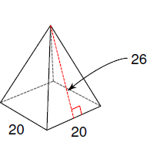
1.

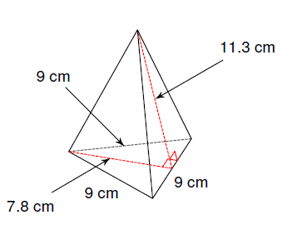
2.

3. The Great Pyramid of Giza is a square pyramid with each side measuring 750 feet and the slant height of the pyramid is 480 feet. What is the surface area of the Great Pyramid?

Surface Area of Pyramids Practice
1.

2.

3. The Great Pyramid of Giza is a square pyramid with each side measuring 750 feet and the slant height of the pyramid is 480 feet. What is the surface area of the Great Pyramid?

