Name:____________________
Transformations Review

- Matching: Match the terms in the left column with the correct definitions or examples in the right column.

1. _____ | Reflection | a. (x, y)
2. _____ | Translation | b. reducing or enlarging a figure on a coordinate plane
3. _____ | Rotation | c. a turn that moves 1 quadrant
4. _____ | X axis | d. the same direction as a clock
5. _____ | Y axis | e. moving a figure by flipping it in a coordinate grid
6. _____ | Dilation | f. the vertical axis (up and down)
7. _____ | Coordinate plane | g. a numbered grid with x and y axis
8. _____ | 90 degree rotation | h. moving a figure by sliding it in a coordinate grid
9. _____ | Clockwise | i. the horizontal axis (across)
10. _____ | Ordered Pair | j. moving a figure by turning it in a coordinate grid

List the x,y rule to find the following coordinates. Discuss how you would solve a transformation with these rules (written or verbally)

- Translation of 7 left and 4 down
- Translation of 3 right and 5 up
- Reflection on the x-axis
- Reflection on the y-axis
- 90° clockwise rotation
- 90° counterclockwise rotation
- 180° rotation
- Dilation of 1/3
- Dilation of 4
II. Application:

- On the coordinate grids provided, transform the figures as directed.
- Use prime notation to label each point on the coordinate grid.
- Write the ordered pairs for the coordinates of the new image below for each problem.

Plane 1 - Translate triangle ABC x-4, y+1.

A’ __________ B’ __________ C’ __________

Plane 2 - Reflect trapezoid DEFG over the x axis.

D’ __________ E’ __________ F’ __________ G’ __________

Plane 3 - Rotate parallelogram HIJK over the 180 degrees.

H’ __________ I’ __________ J’ __________ K’ __________

Plane 4 - Dilate square LMNO by a scale factor of 2.

L’ __________ M’ __________ N’ __________ O’ __________

Plane 5 - Rotate rectangle PQRS 90 degrees clockwise about the origin.

P’ __________ Q’ __________ R’ __________ S’ __________

Plane 6 - Dilate square TUVW by a scale factor of ½ .

T’ __________ U’ __________ V’ __________ W’ __________

Plane 7 - Plot triangle XYZ on the coordinate grid using the following coordinates:

X (-4, 4) Y (-4, -2) Z (-1, -2)

Reflect the figure over the y-axis, then translate x-2, y+1.

Plane 8 – The pre-image and image have been graphed. Explain the transformations that were applied to get to the image.

1
2
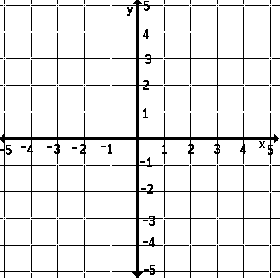

A
B
C

D
E
F
G

4
3

L
M
N
O

H
I
J
K

6
5

U
T
Q
P

W
V
S
R

8
7
IMAGE
PRE-IMAGE

