1) ______________________  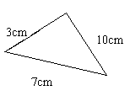 | 2) ______________ 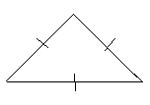
3) ________________________________  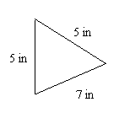 | 4) ______________________________  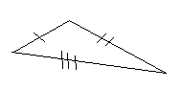
Triangle Info Homework Name:_____________________________
For #1-4, name the triangle
For numbers 5-8, find the missing side length.
5) The perimeter of an equilateral triangle is 45cm. What is the length of each side? | 6) If the perimeter of the triangle below is 36in find the value of x and the length of each side.  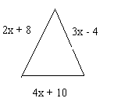
7) Two sides of an isosceles triangle are 4 less than twice the value of the third side. If the perimeter of the triangle is 42cm, what is the value of x? What are the lengths of the 3 sides? | 8) The perimeter of an equilateral triangle is 108in. Find the length of each side.  An isosceles triangle has the same perimeter, what can be the lengths of the sides?
For numbers 9-12, state whether the sides can form a triangle
9) 2cm, 6cm, 4cm | 10) 9cm, 11cm, 4cm
11) 15cm, 7cm, 9cm | 12) 60cm, 60cm, 20cm

