Name______________________________________Date_______Core_____

(Calculator Active)

Common Core Math 7+ - Unit 5 Test Review

*For each problem, be sure to follow the directions to determine the answer.*

*All answers should be in simplest form.*

|  |  |  |  |
| --- | --- | --- | --- |
| 1. The scale of a map is 1.25 in. = 80 mi. If two cities are 4.75 inches apart on the map, how many miles apart are the cities? | | 2. During a trip, a car traveled 249.2 miles in 4 hours. What was the speed of the car? | |
| 3. Two drinks are on sale at a store.  Drink A costs $1.28 for 16 ounces. Drink B costs $2.16 for 24 ounces. Determine the unit rates, and find which drink costs less per ounce. | | 4. A girl that is 4 feet tall is standing next to the Empire State Building in New York City. The girl’s shadow is 3.2 feet long. If the Empire State Building is 1454 feet tall, how long would its shadow be? | |
| 5. A 7-foot man casts a shadow of 10 feet. At the same time of day, a nearby tree casts a 35-foot shadow. Using similar triangles, set up 3 different possible proportions. | | 6. Seven bananas contain 3.5 milligrams of Vitamin B6. How many bananas contain 9.31 milligrams of Vitamin B6? Round to the nearest tenth. | |
| 7. A worker at a tire shop can install 4 new tires in 1.3 hours. At this rate how long would it take the worker to install new tires for 75 cars if each car will receive 4 tires? | | 8. Terry paid $8.75 for 5 pounds of pears. At this rate how many pounds of pears could she buy with $61.25? | |
| 9. Trail mix was made by combining almonds and grapes in a 4:3 ratio. If 21 ounces of grapes were used, how many ounces of almonds were used? | 10. A group of students will be taking a field trip and there needs to be one chaperone for every 8 students. How many chaperones are needed for 136 students? | |
| 11. Two parallelograms are similar. The dimensions of the smaller parallelogram are 4 inches by 12 inches. If the larger parallelogram has a longer side length of 39 inches, use proportions to find the shorter side. | 12. The following chart shows the pay a babysitter made for different hours of work. Does the babysitter’s pay represent a proportional relationship?   |  |  | | --- | --- | | **Number of hours** | **Pay** | | 0 | $0 | | 2 | $15 | | 3 | $24.75 | | 11 | $107.25 | | |
| 13. Find the value of D if the smaller rectangle inside of the larger is similar.  5 D  10 | | |
| 14. Fill in the following table and identify the constant of proportionality.   |  |  | | --- | --- | | **Minutes** | **Words Typed** | | 12 | 96 | | 6 |  | | 3 |  | | 1 |  |   Constant of Proportionality = _________ | 15. If the trapezoid below is enlarged using a scale factor of 6, what will be the ***perimeter*** of the new trapezoid?  20 mm    17 mm 17 mm    9 mm | |

16. Which car is traveling at the *fastest* speed?

Car A

Car B

Car C

Car D

0 5 10 15 20

60

45

30

15

0

distance

Time (minutes)

0 5 10 15 20 25 30

60

50

40

30

20

10

0

distance

Time (minutes)

0 10 20 30 40

10

8

6

4

2

0

distance

Time (minutes)

0 5 10 15 20

100

80

60

50

40

30

20

10

0

distance

Time (minutes)

17. Sarah is planning to swim across the lake in a nearby park. Before she started to practice, she wanted to know how far she would have to swim. She drew a diagram of the lake.

What is the length of the lake that Sarah will swim across?

5 m

7 m

77 m

**X**

18. The diagram represents a run-away emergency truck ramp beside the highway in the mountains.

What is the incline slope of the ramp?

60 feet

1200 feet

19. What equation represents line *w?*

a)

b)

c)

d)

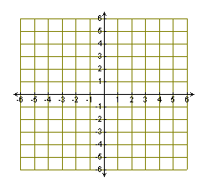

*w*

20. When something has a scale factor of 6, what does that mean?

21. What do the different parts of the equation y=mx+b mean?

22. What does slope mean?

23. What are the 4 different types of slope and what do they look like?

Find the slope using the coordinate points, equation, or graph.

24. (15, 8) and (-17, 9) 25. (12,2) and (-7, 5)



26. . 27.

28. y = -x + 2 29. X = 4

Write the equation that goes with the coordinate points or graph

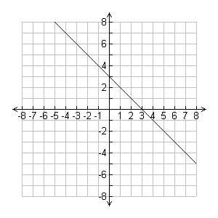

30. ___________________

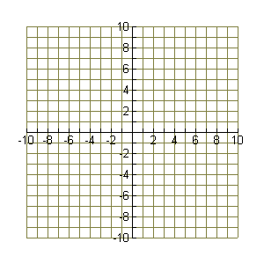

31. ____________________

(2, 4) and (0,-2)