Volume of Prisms Homework

Find the volume the prisms. Be sure to show all steps when using a calculator.
1.  V= | 2.  V=
3. The length of a rectangular prism is 11 m, the width is 8 m. Find the height if the volume is 1408 m³.  H= | 4.  V=
5. A rectangular prism has a square base with side lengths that are 3.5 feet. The prism stands 6 ft tall. What is the volume of the prism?  V= | 6.  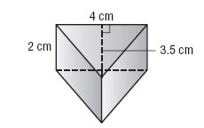  V=
7.  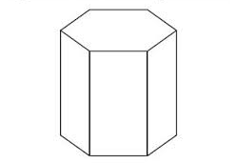  H = 5 ft  B = 13 ft  V= | 8. Mr. Riojas is building his children a sandbox that is shaped like a triangular prism. He uses 7-foot long wooden beams for each side of the base. He measures the height of the triangular base to be $7\frac{13}{16}$ feet. If he makes the sandbox 1 foot tall, how much sand will he need to fill it? Round to the nearest cubic foot.  V=

